Salesforce Admin Practice – Ticket Documentation

✅ Ticket 01 – Lead Form Standardization
📌 Business Problem
Marketing reported inconsistent and incomplete lead data.
Important details such as phone numbers, budget, and source information were often missing, impacting reporting and follow-ups.

🎯 Objective
Standardize lead capture and enforce mandatory data entry.

🛠 Solution Implemented
Custom Fields Created
- Lead Source Detail (Picklist)
- Budget (Currency)
- Priority (Picklist)
- Expected Purchase Date (Date)
Data Validation
- Phone field made mandatory using Validation Rule
UI Improvements
- Updated Lead Page Layout
- Grouped fields under Lead Information section

⚙️ Steps Performed
- Object Manager → Lead → Fields & Relationships → Created fields
- Added Validation Rule:
- ISBLANK(Phone)
- Updated Page Layout
- Tested record creation

🧪 Testing
- Lead without Phone → Save blocked
- Lead with Phone → Saved successfully
- All new fields visible

📸 Evidence
Fig 1–4

✅ Outcome
- Improved data completeness
- Reduced missing information
- Better reporting quality

Fig 1: Validation Rule configuration enforcing Phone as mandatory before saving a Lead.
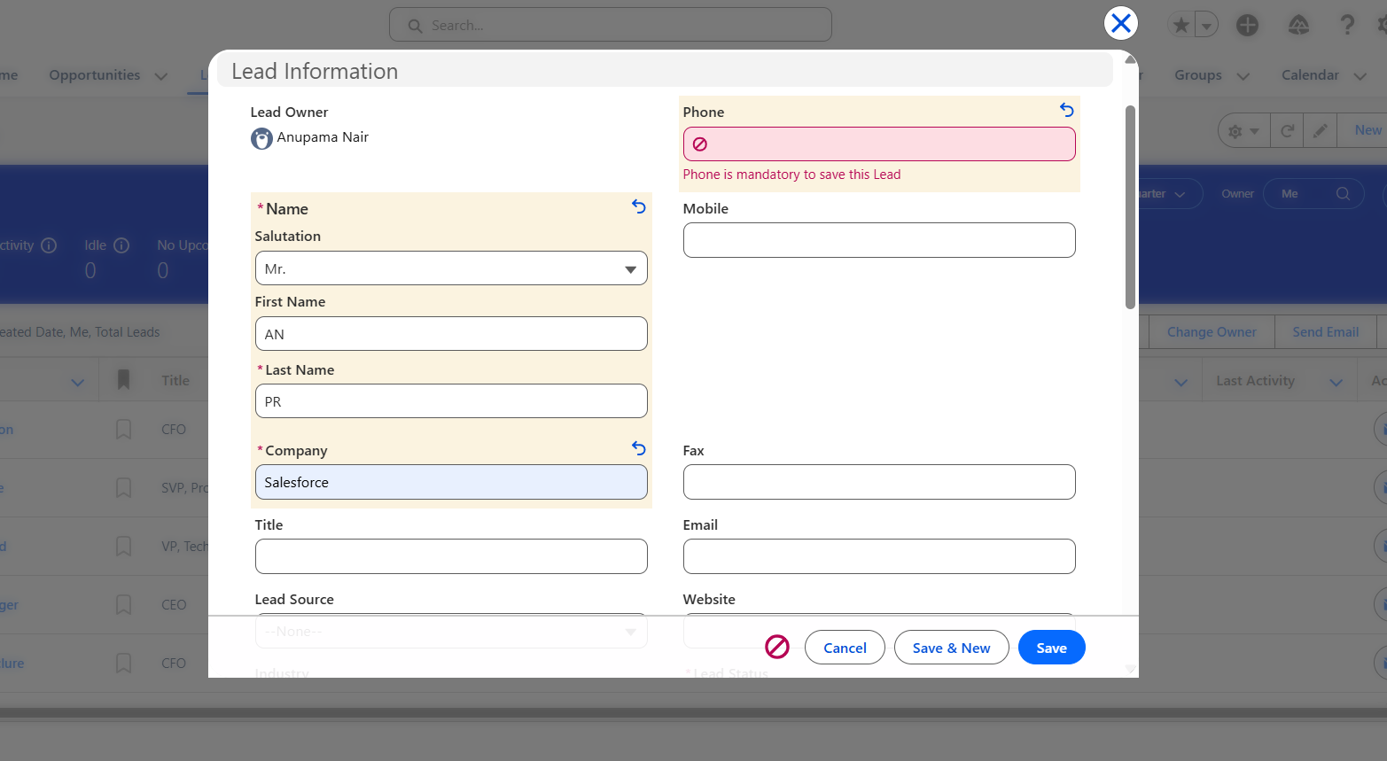
Fig 2: Record save attempt without Phone showing validation error message.

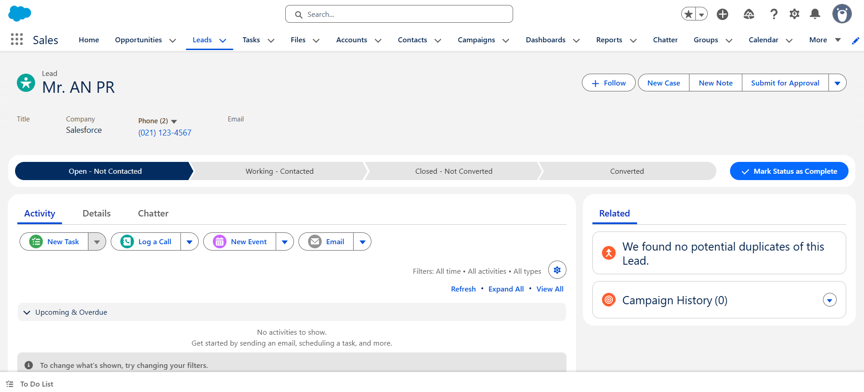
New fields and picklists
Fig 3: Custom Lead fields created (Budget, Priority, Lead Source Detail, Expected Purchase Date).
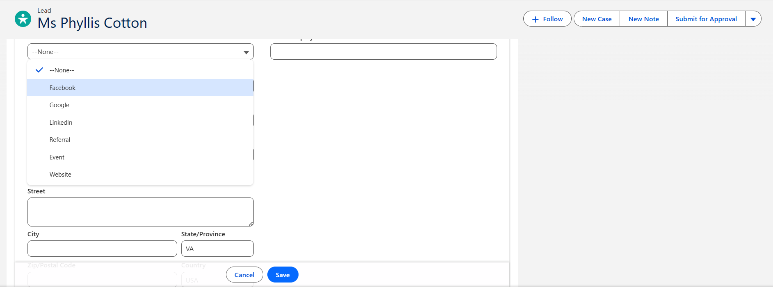

Fig 4: Lead page layout showing new fields placed under Lead Information section.
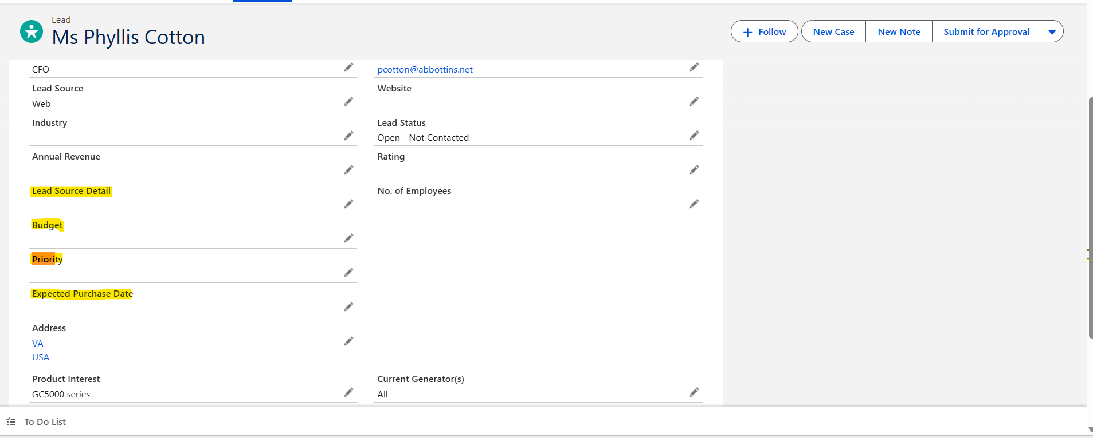
✅ Ticket 02 – Bulk Lead Import & Cleanup

📌 Business Problem
Marketing provided 200+ leads in Excel format requiring bulk upload and cleanup.

🎯 Objective
Import leads efficiently while preventing duplicates.

🛠 Solution Implemented
- Cleaned CSV data
- Standardized country values
- Removed duplicates using Email
- Imported using Data Import Wizard
- Created List View for tracking imports

⚙️ Steps Performed
- Prepared CSV file
- Setup → Data Import Wizard → Leads
- Mapped fields
- Duplicate matching by email
- Imported records
- Created List View “Today’s Imports”

🧪 Testing
- Verified record count
- Checked field mapping
- Confirmed no duplicates

📸 Evidence
Fig 5–8

✅ Outcome
- Faster bulk onboarding of data
- Clean dataset
- Reduced manual entry

Fig 5: CSV file uploaded using Data Import Wizard.

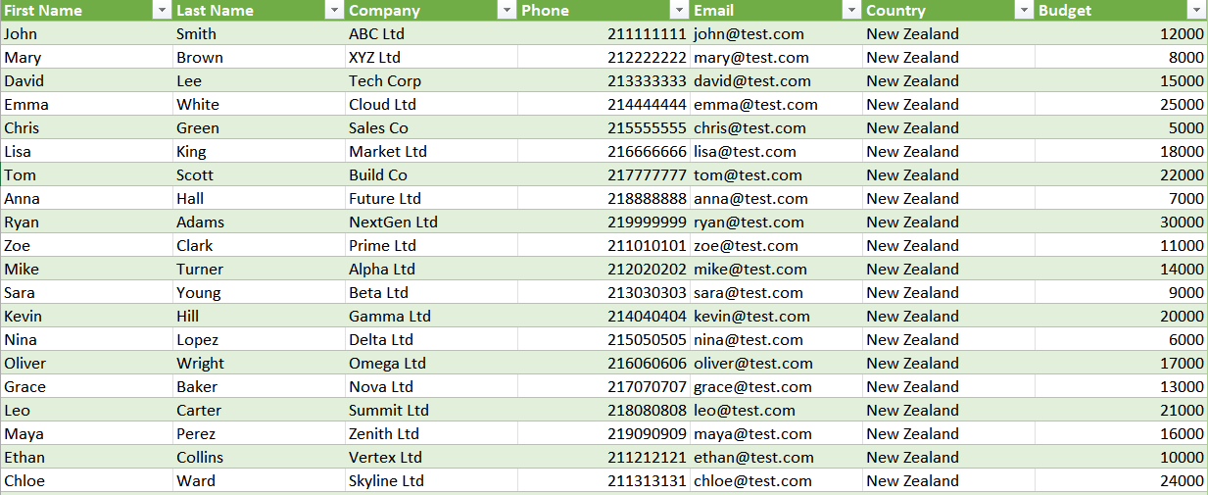

Fig 6: Imported Lead record details showing correct Email and Phone mapping.
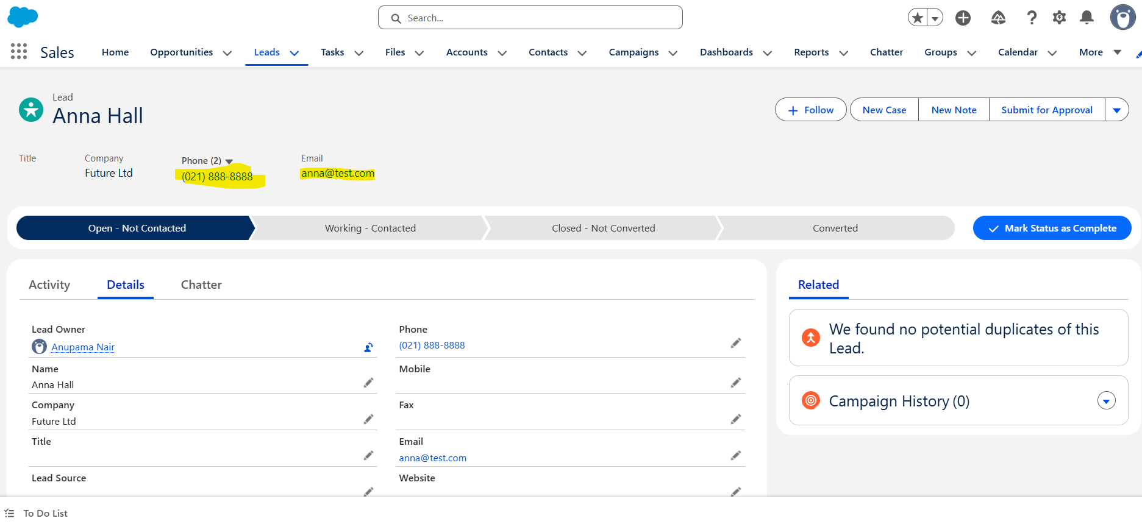

Fig 7: Budget and address fields populated correctly after import.
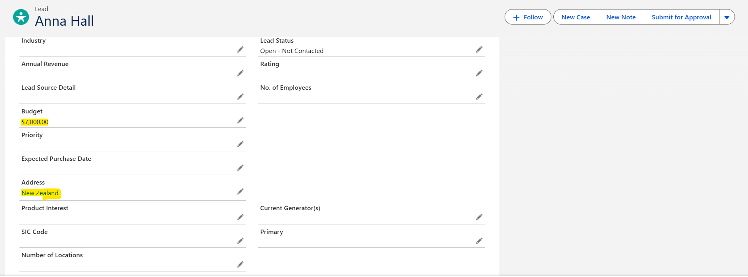
Fig 8: List view/report confirming no duplicate records present. No duplications
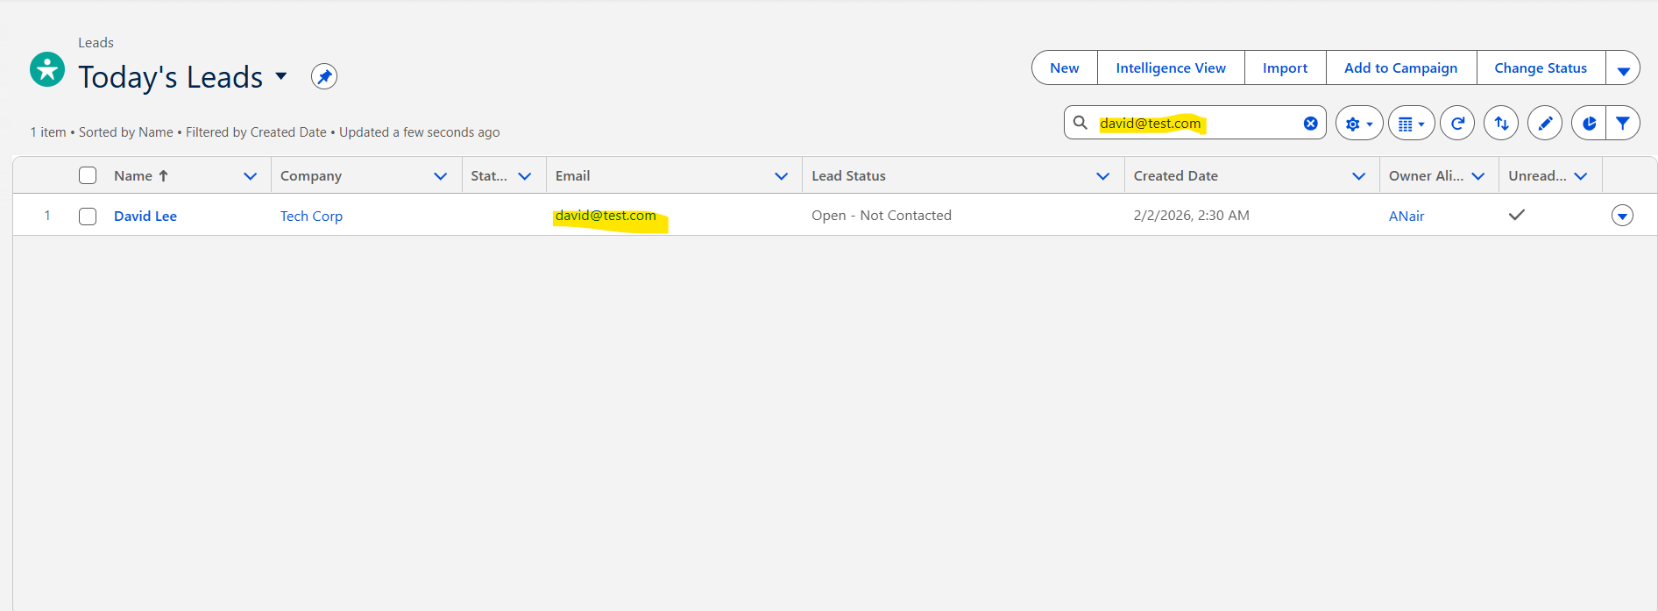
✅ Ticket 03 – Sales KPI Dashboard
📌 Business Problem
Sales managers lacked visibility into lead performance and conversion metrics.

🎯 Objective
Create interactive reports and dashboard for insights.

🛠 Solution Implemented
Reports Created
- Leads by Source
- Leads by Priority
- High Budget Leads (>10,000)
- Total Lead Count
Dashboard Built
Sales KPI Dashboard with:
- Pie Chart
- Bar Chart
- Table
- Gauge/Metric

⚙️ Steps Performed
- Built reports using grouping & filters
- Added visual charts
- Created Dashboard
- Added components

🧪 Testing
- Charts display correct segmentation
- Counts match dataset
- Dashboard updates automatically

📸 Evidence
Fig 9–14

✅ Outcome
- Real-time visibility
- Faster decision making
- Clear performance metrics

Fig 9: Leads by Source report grouped by Lead Source Detail.
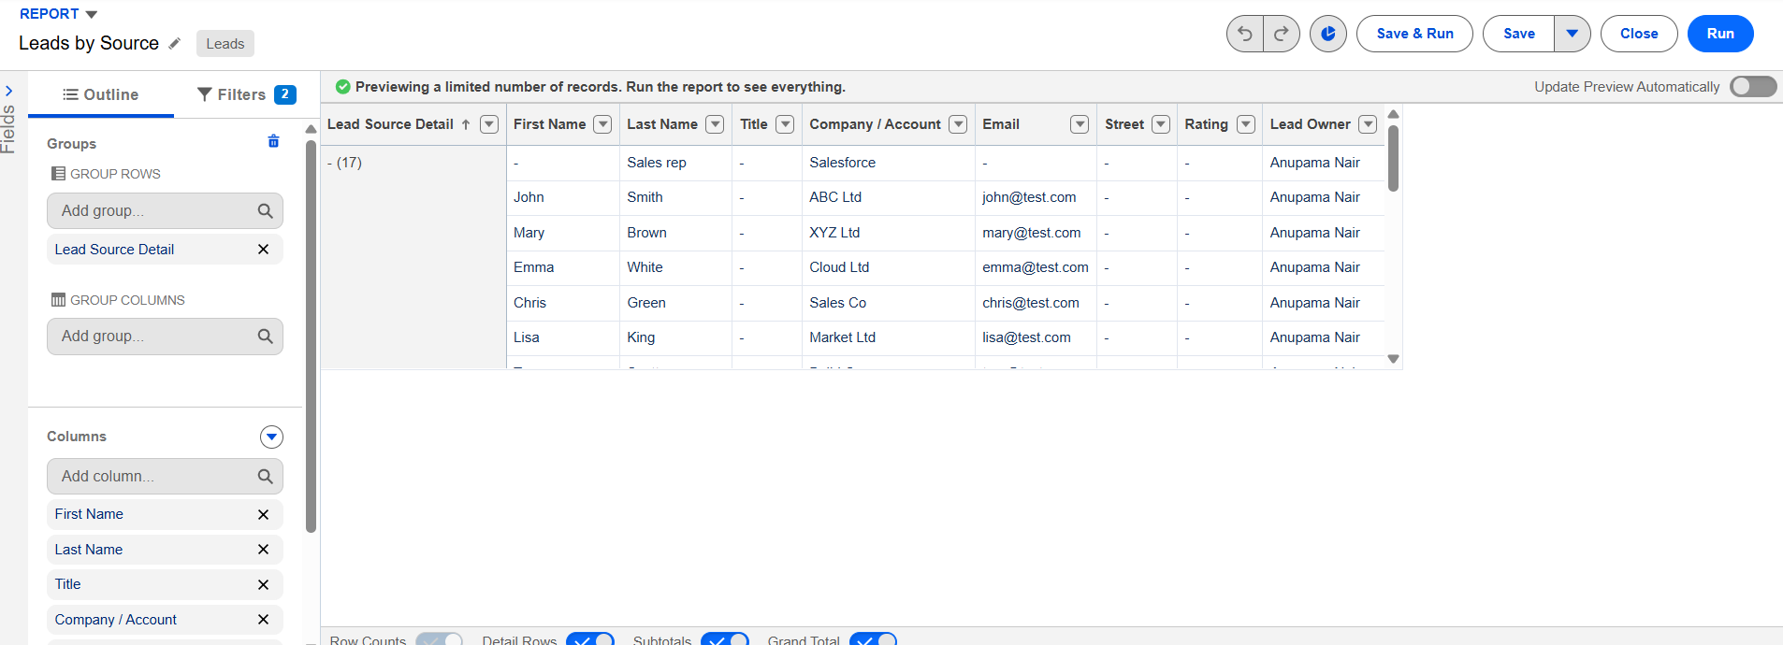

Fig 10: Leads by Priority report with bar chart visualization.
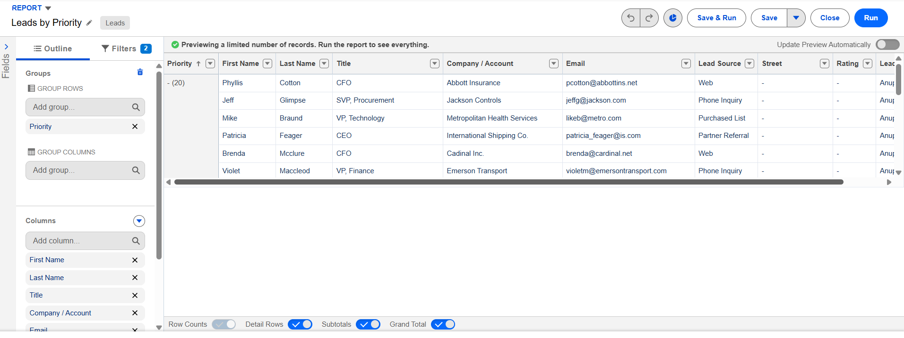
Fig 11: High Budget Leads filtered report (Budget > 10,000).
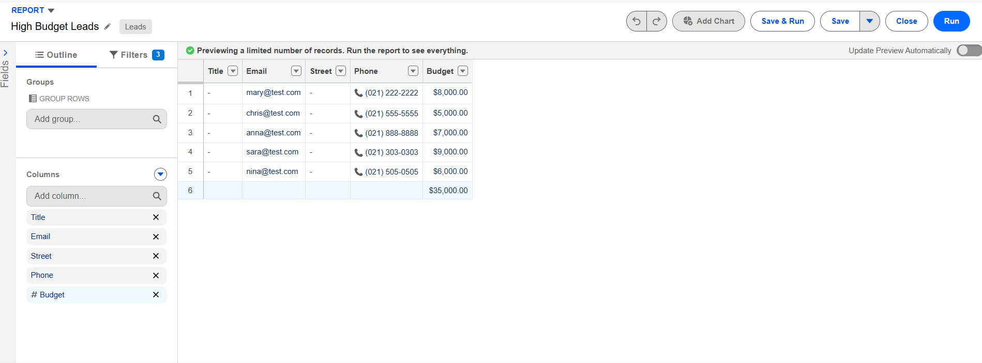

Fig 12: Total Leads report showing overall row count.
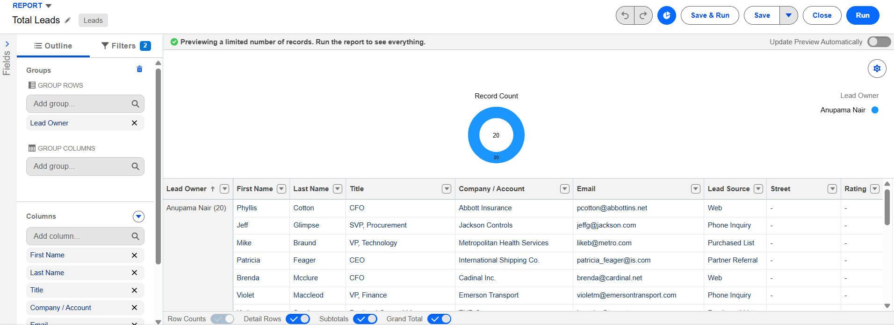

Fig13 : All the reports created as needed
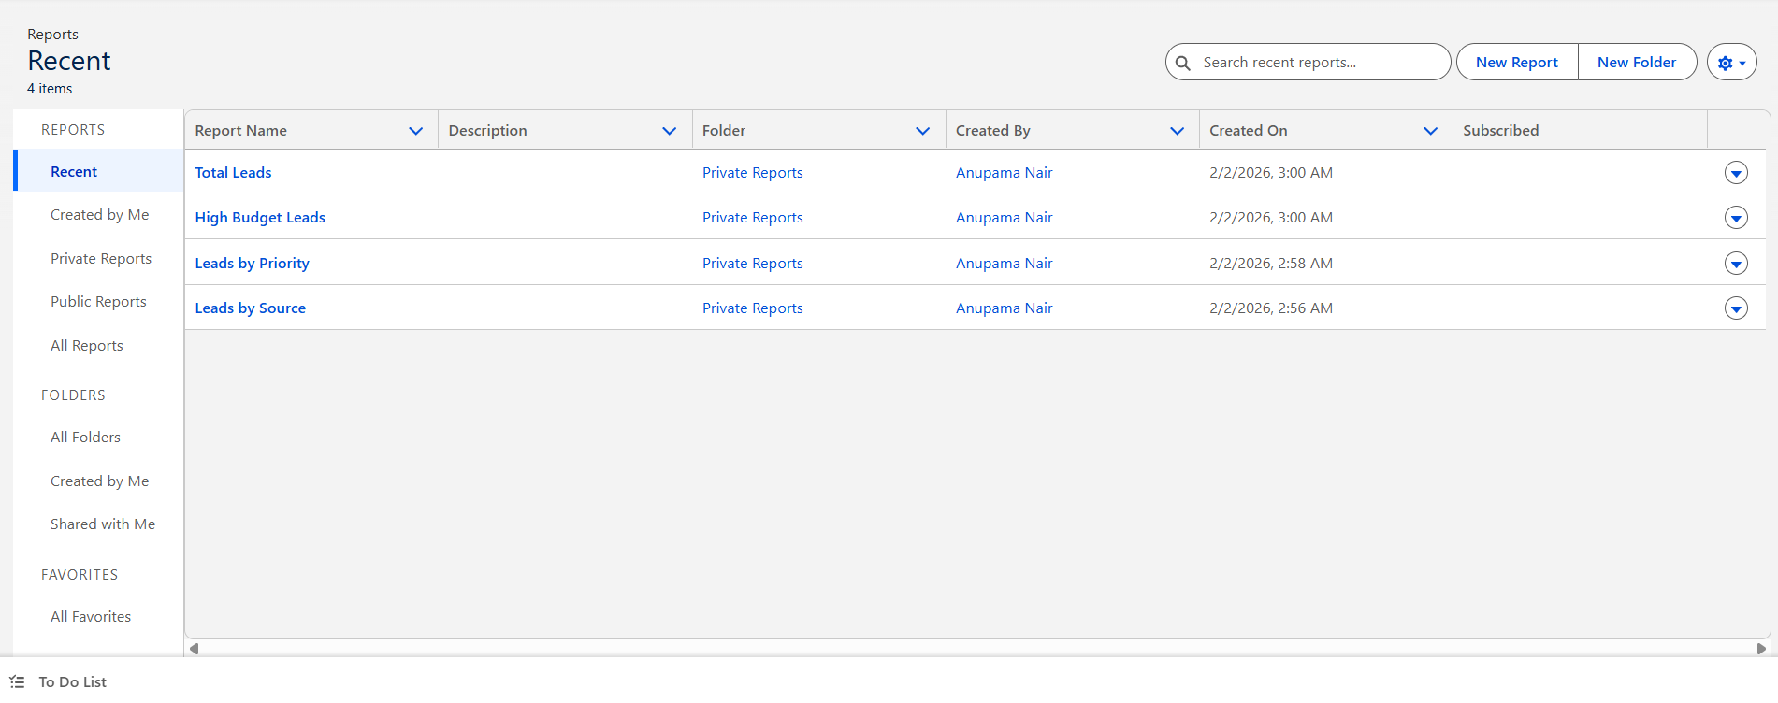
Fig 14: Dashboard creation screen with components being added.
Fig 14: Final Sales KPI Dashboard displaying charts and metrics.
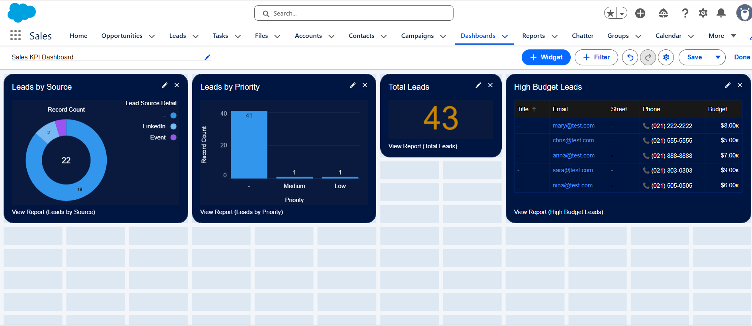

✅ Ticket 04 – Lead Priority Automation (Flow)

📌 Business Problem
Sales reps manually prioritized leads, causing delays and inconsistency.

🎯 Objective
Automatically assign priority based on budget.

🛠 Solution Implemented
Record-Triggered Flow with:
Logic
Budget > 20000 → High
10000–20000 → Medium
<10000 → Low
Actions
Update Priority field automatically

⚙️ Steps Performed
Created Record-Triggered Flow
Added Decision element
Added Update Records actions
Activated flow

🧪 Testing
Created leads with various budgets:
25,000 → High
15,000 → Medium
5,000 → Low

📸 Evidence
Fig 15–24

✅ Outcome
Eliminated manual work
Consistent prioritization
Faster sales response

Fig 15: Record-Triggered Flow setup for Lead object.
: Flow canvas showing complete connected logic and activation.

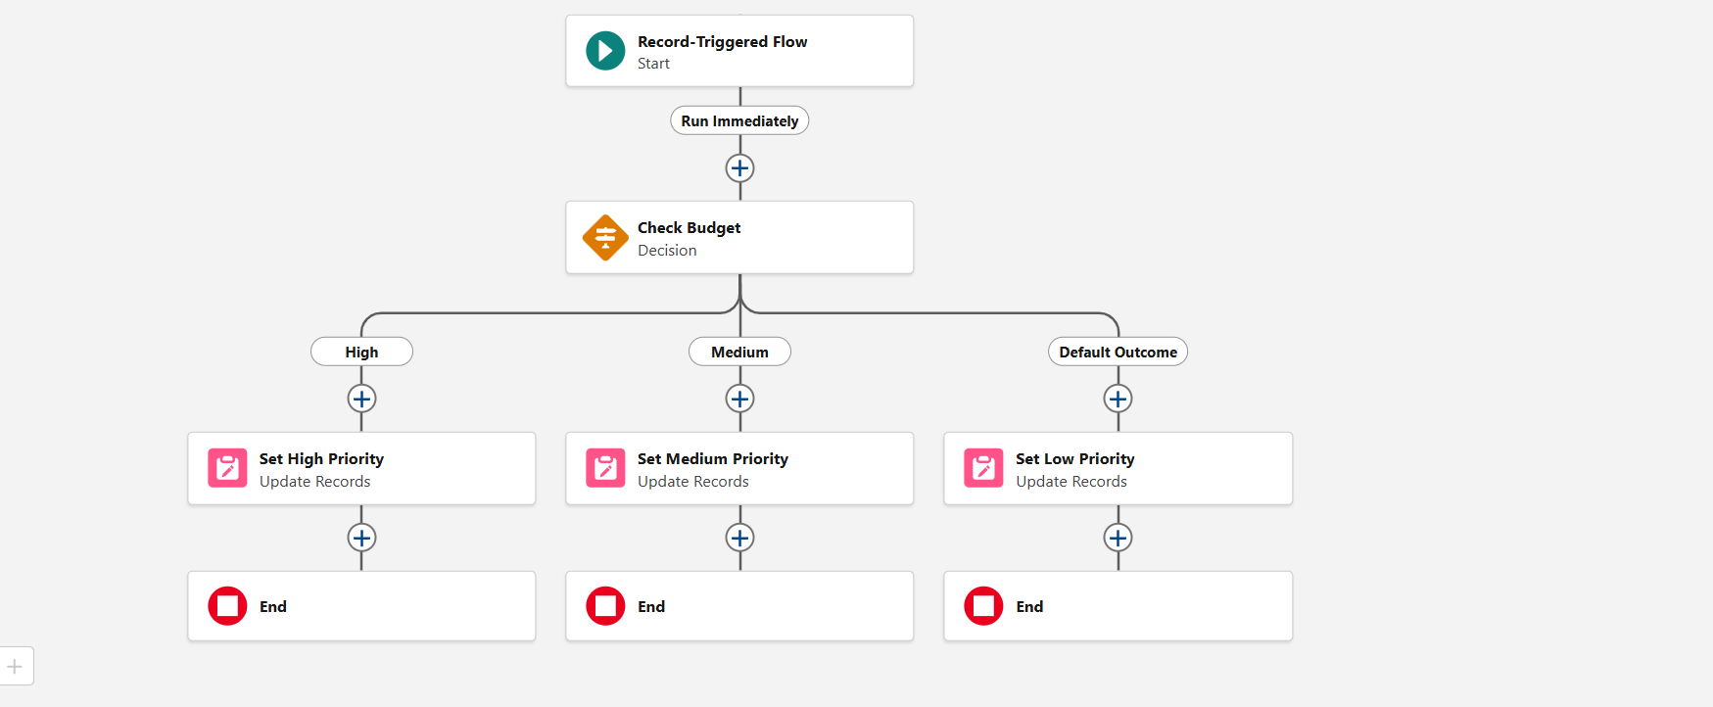

Fig 16: Flow Start configuration set to run on create/update.
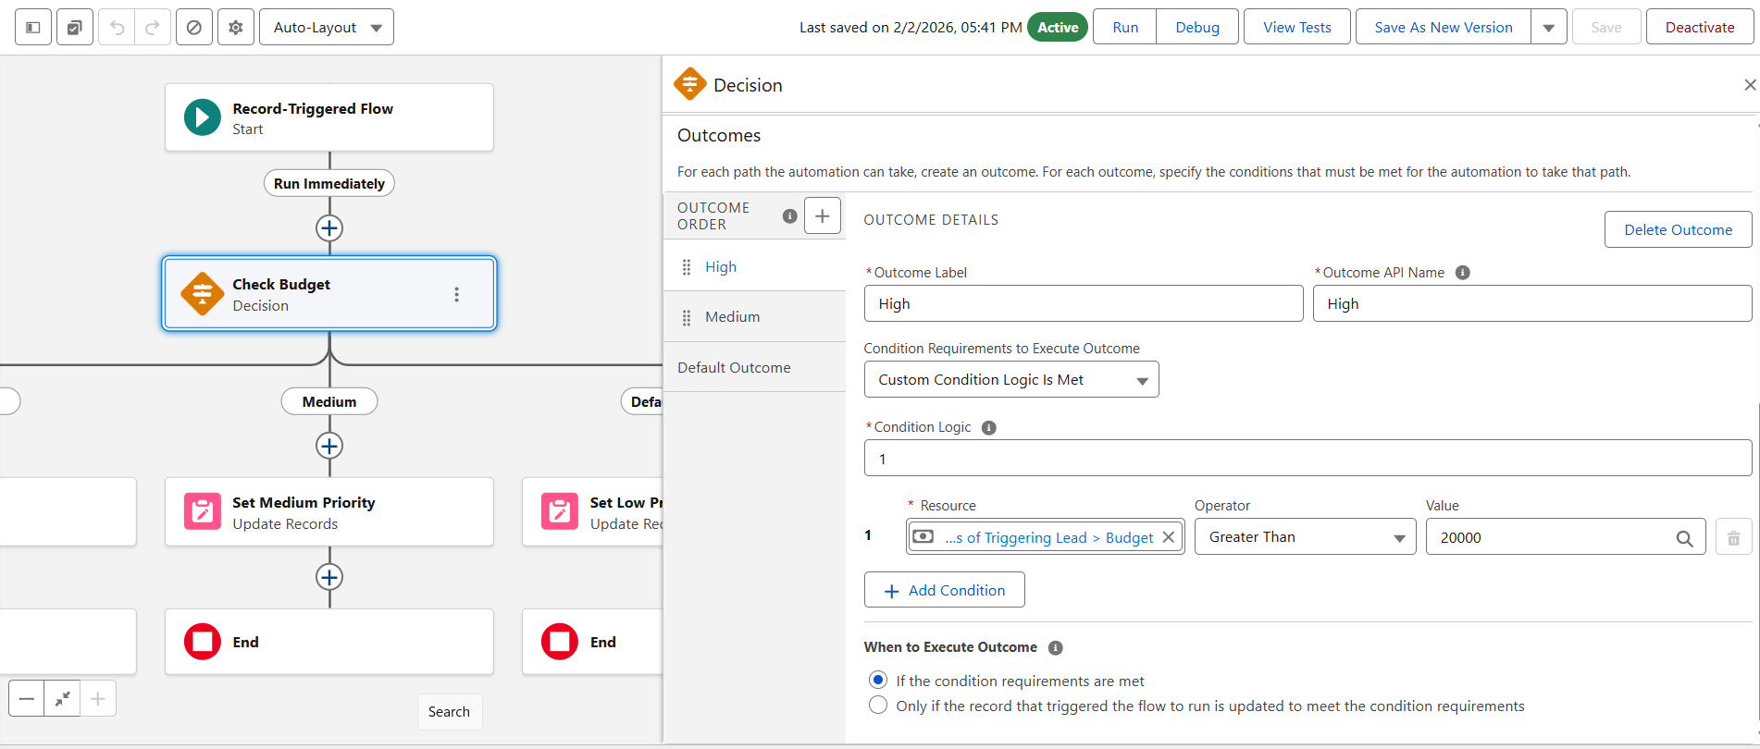

Fig 17: Decision element checking Budget thresholds.
Fig 18: Outcome configuration for Medium priority condition.

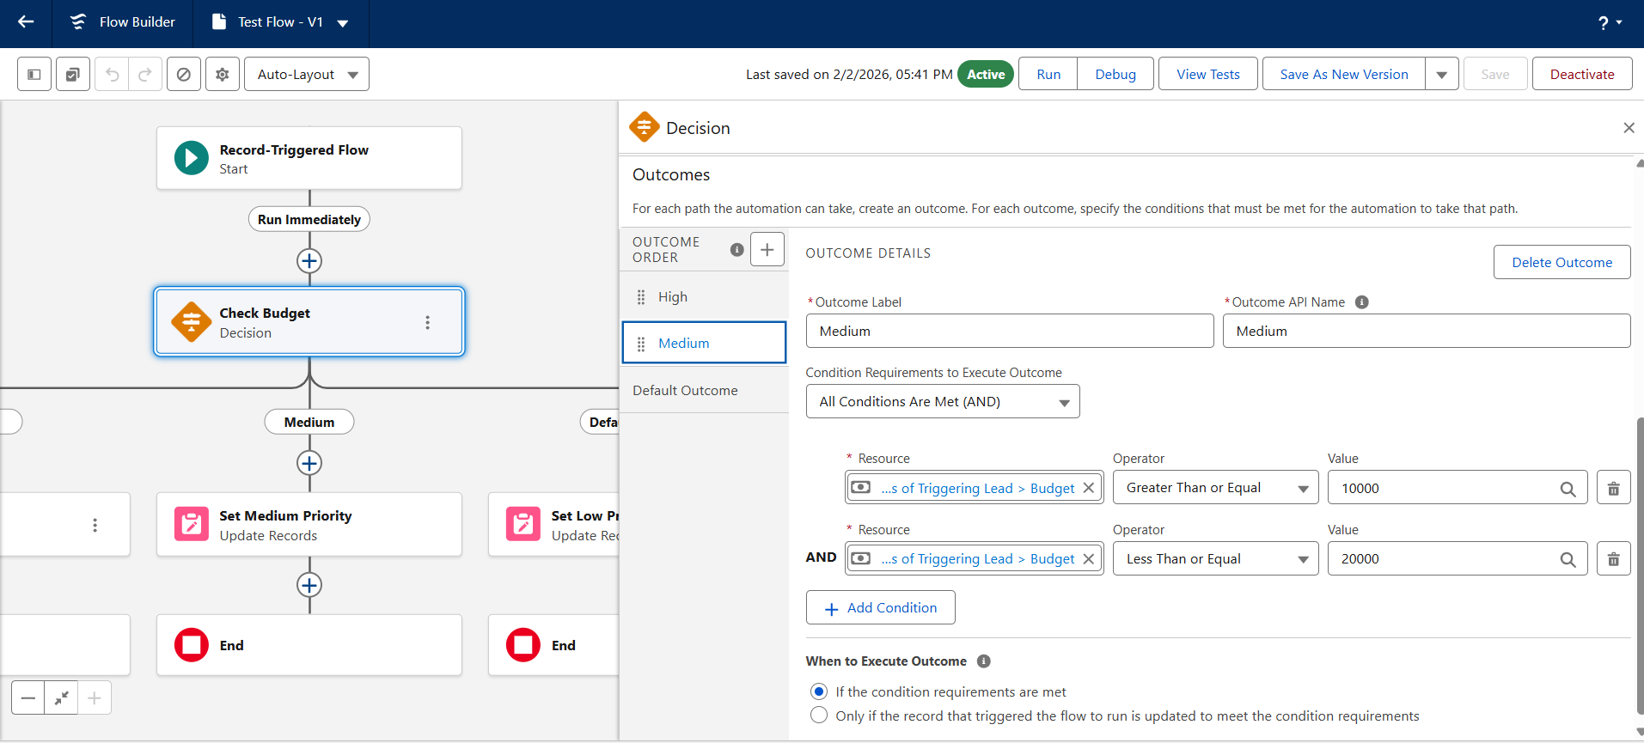

Fig 19: Outcome configuration for High priority condition.
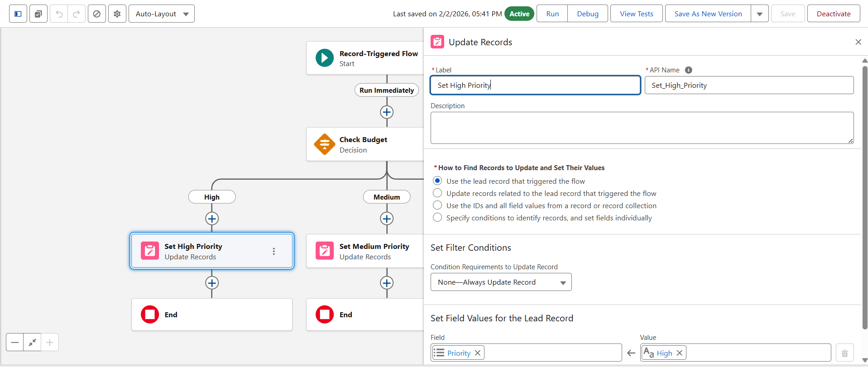

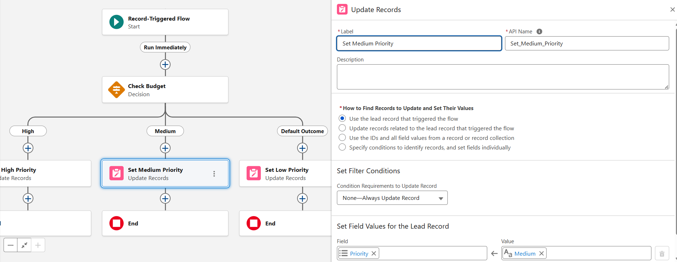

Fig 20: Default outcome representing Low priority.
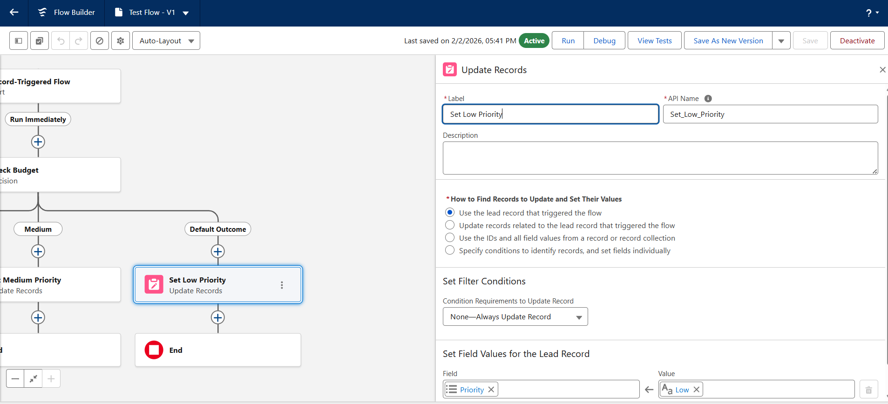

Fig 21: Update Records element for High priority.
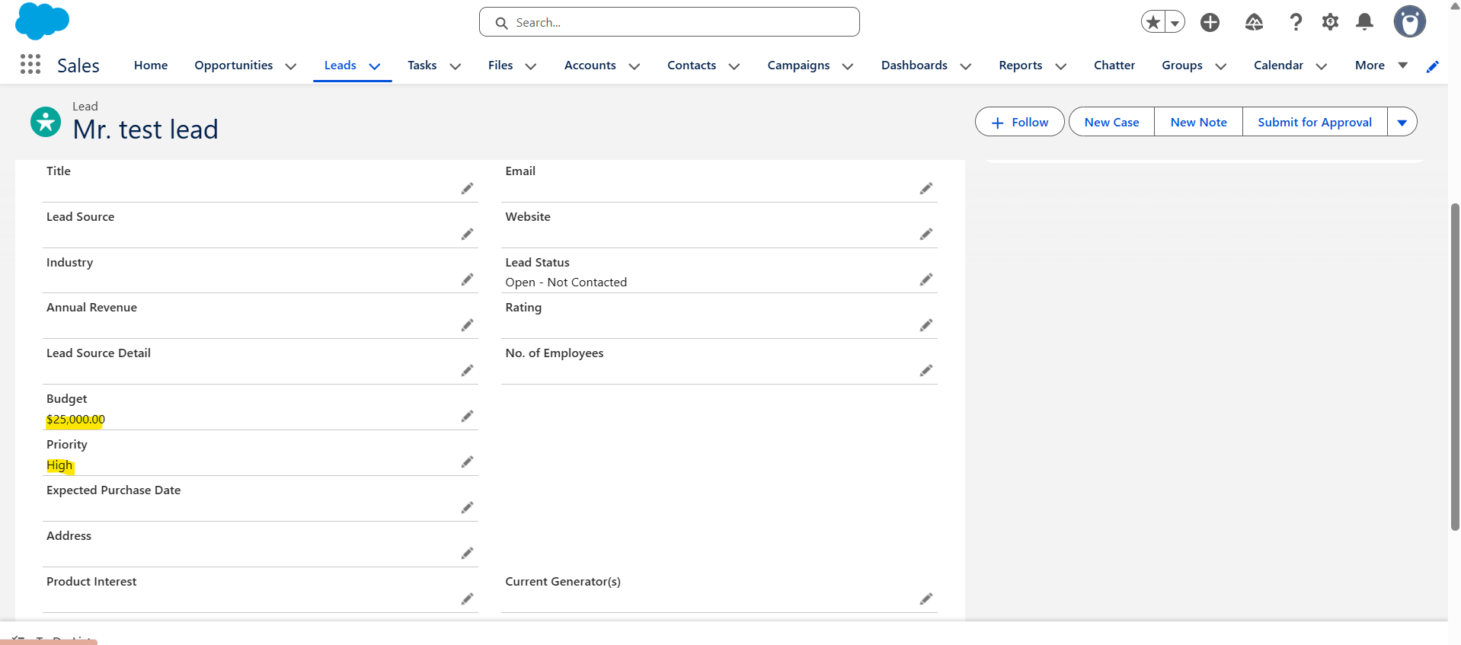
Fig 22: Update Records element for Medium priority.

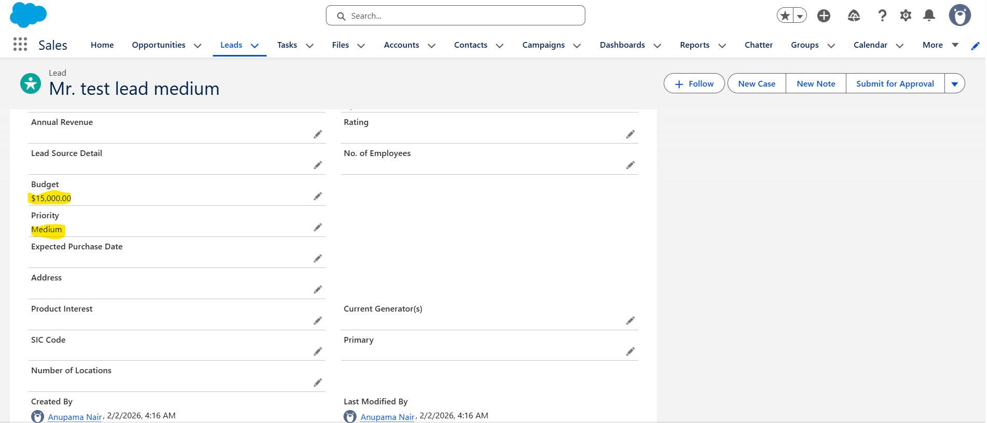

Fig 23: Update Records element for Low priority.
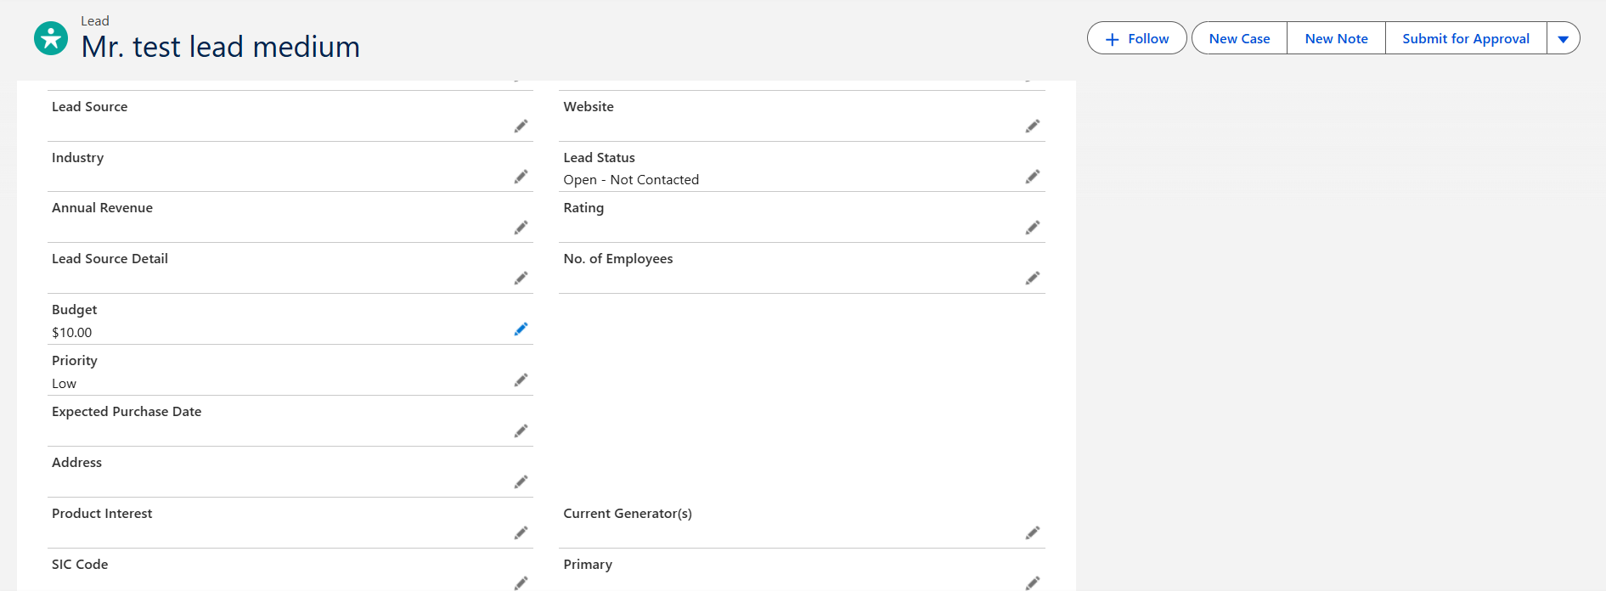

✅ Ticket 05 – High Priority Email Alerts
📌 Business Problem
High-value leads were not being addressed quickly due to lack of notifications.

🎯 Objective
Notify sales instantly when a high-priority lead is created.

🛠 Solution Implemented
Flow with:
- Decision (Priority = High)
- Send Email action
- Dynamic merge fields

⚙️ Steps Performed
- Created Record-Triggered Flow
- Added Decision for Priority
- Added Send Email action
- Configured recipient & message
- Activated flow

🧪 Testing
- High priority → Email received
- Medium/Low → No email

📸 Evidence
Fig 25–27

✅ Outcome
- Instant alerts
- Faster response
- Improved conversion

Fig 24: Decision checking if Priority equals High.
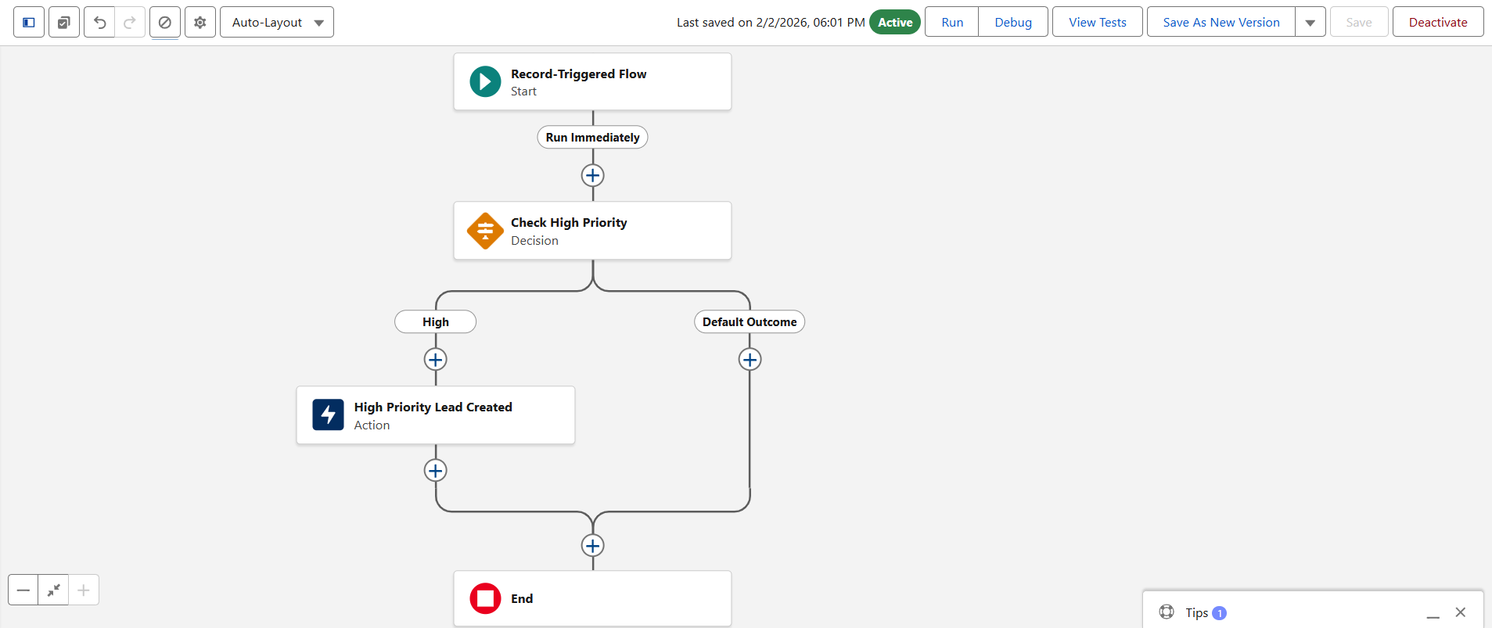

Fig 26: Send Email action configuration with recipient, subject, and body fields.
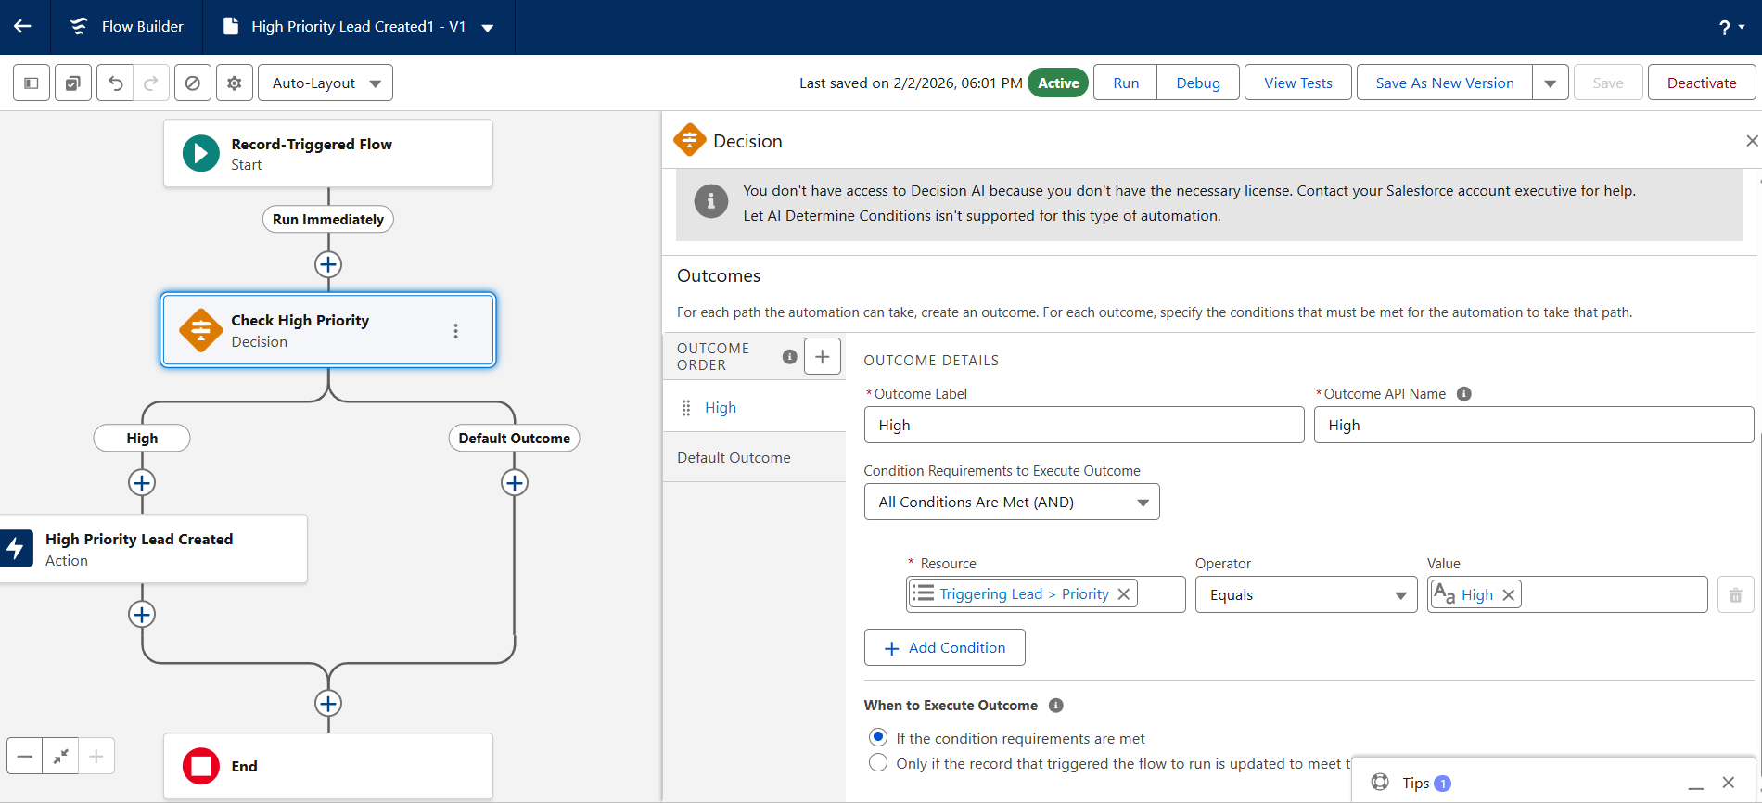

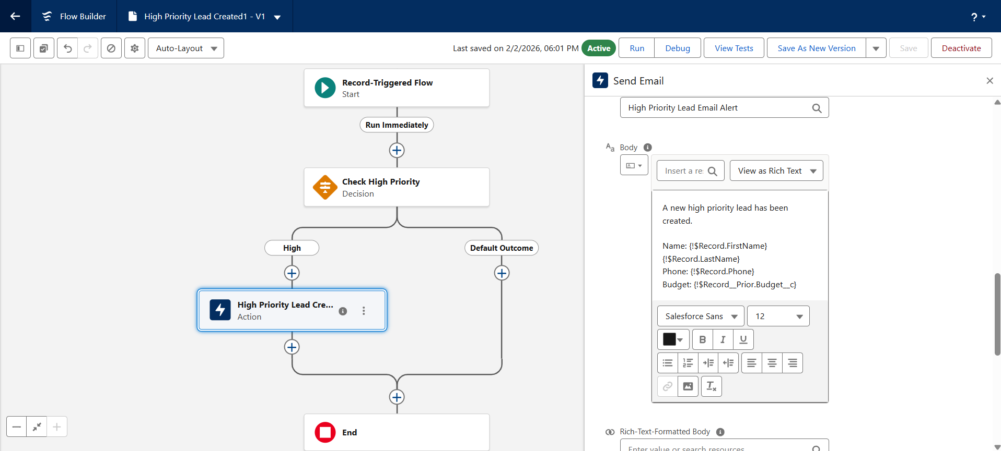

Fig 27: Received email confirmation demonstrating successful automation.
